Scheduler: User Guide

Contents

Clinician Guide 2

Adding a Request 2

Administrator Guide 2

First-Time Setup 2

Calendar Setup 2

Holiday Weekend Setup 6

Configuration File Setup 7

Running the Scheduler 8

Clearing the Schedule 11

# Clinician Guide

## Adding a Request

Make sure you have access to the calendar and permission to create events.

1. Go to <https://calendar.google.com> and sign into your account.
2. Create an event by clicking on a date.
3. Configure the event.
   1. Add a title: [request] <YOUR NAME>, replacing <YOUR NAME> with the name found in the configuration file. (You may ask the administrator for this information)
   2. Set the time and date
   3. Set the calendar to be the appropriate calendar created by the administrator.
4. Click “Save” to save the event.

# Administrator Guide

## First-Time Setup

### Calendar Setup

1. Go to <https://calendar.google.com> and sign into the administrator account.
2. 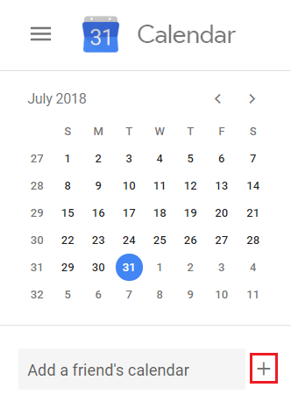Click on the “plus” symbol on the right-hand side.
3. 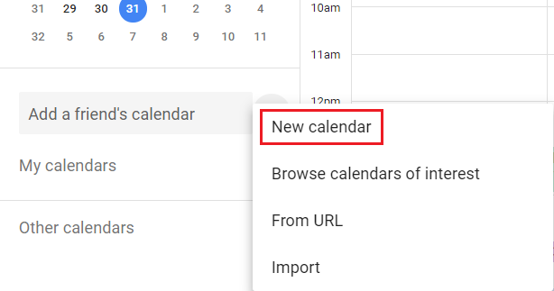Select “New Calendar”.
4. 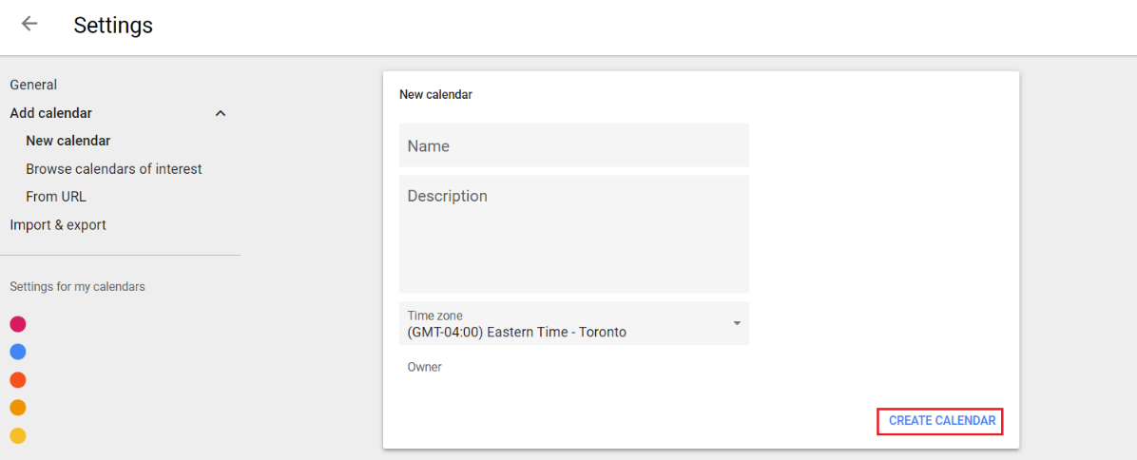Enter an appropriate Name and Description, and press “Create Calendar”.
5. 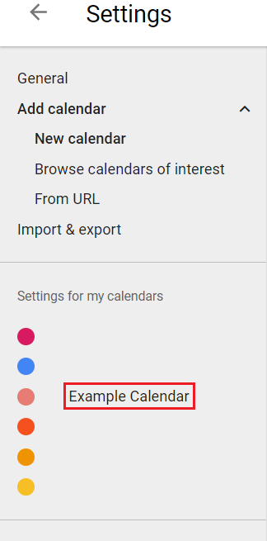Click on the newly created calendar on the right-hand side.
6. 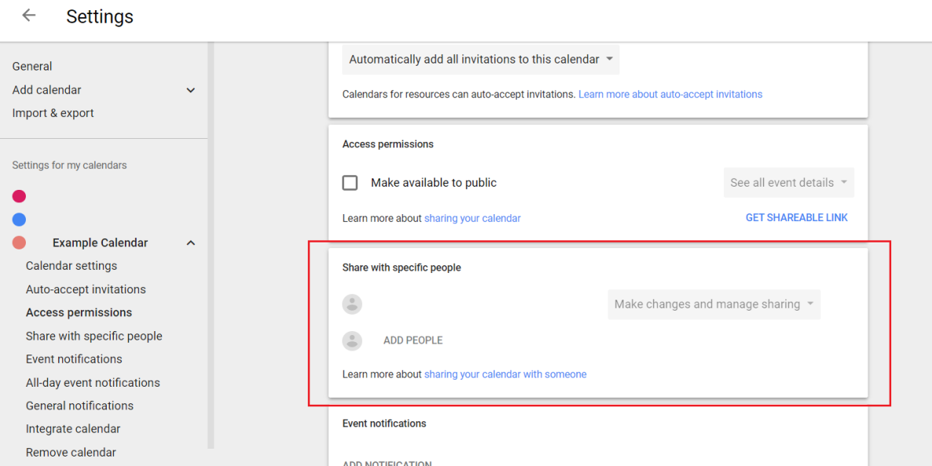 Scroll to “Share with specific people”.
7. Click on “Add People” and fill out the necessary details for each clinician. **Make sure to set “Permissions” to “Make changes to events”**.

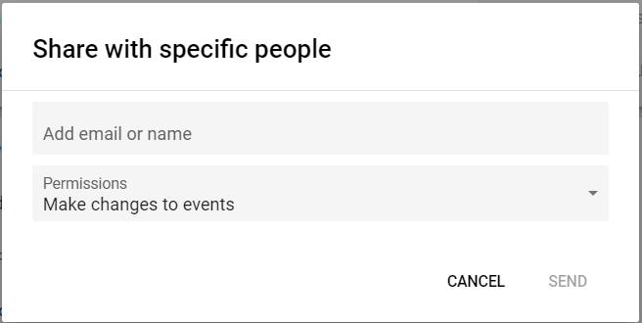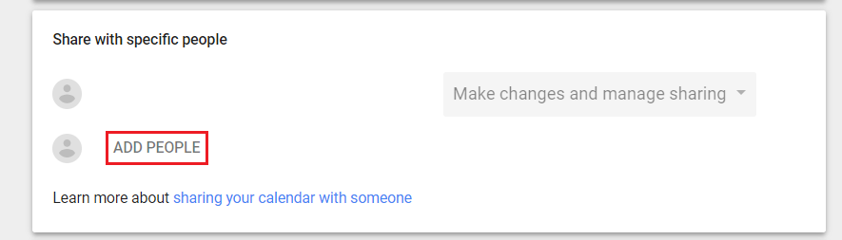

### Holiday Weekend Setup

In order to assign holiday weekends correctly, the scheduler needs to read them from the calendar.

1. Go to <https://calendar.google.com> and sign into your account.
2. Create an event by clicking on a date.
3. Configure the event.
   1. Add a title: [holiday] <additional info>, adding any additional information, if necessary
   2. Set the time and date
   3. Set the calendar to be the appropriate calendar used for scheduling.
4. Click “Save” to save the event.

### Configuration File Setup

1. Open a command prompt (Start 🡪 All Programs 🡪 Accessories 🡪 Command Prompt).
2. In the command prompt, navigate to the location of the programs.
   1. 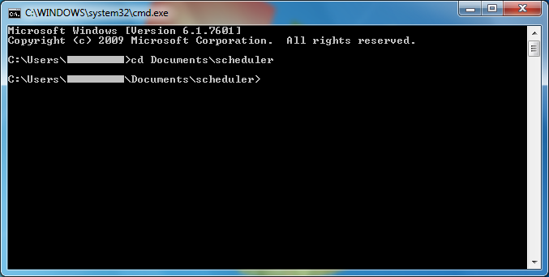Type: cd <path\to\program> (replace with correct path) and press enter.
3. Create a new folder to store configuration files
   1. 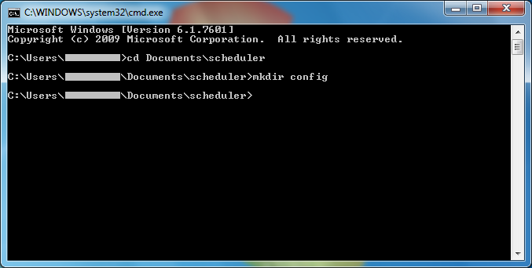Type: mkdir config and press enter.
4. Create a new configuration file
   1. 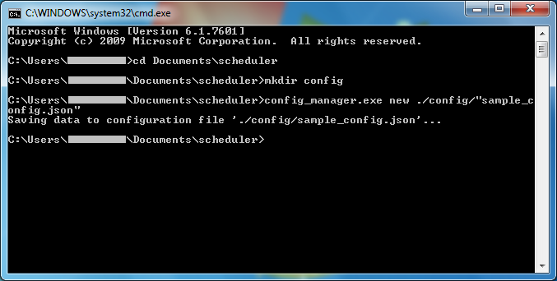Type: config_manager.exe new ./config/“<filename>” (replace <filename> with your choice of a name) and press enter
5. Add clinicians
   1. Every clinician needs to be added separately. Type: config_manager.exe add ./config/“<filename>” “<clinician>” “<email>” (replace <filename> with the name you chose in step 4a; replace <clinician> with the name of the clinician and <email> with the email address corresponding to the clinician that was added when setting up the calendar)
   2. 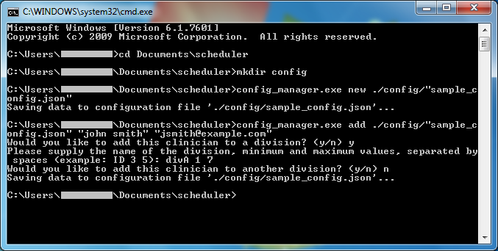Once you press enter, you will be asked to add the new clinician to a division. Follow the instructions printed in the command prompt (typing y for yes or n for no when indicated)

## Running the Scheduler

Once you have setup the calendar and the configuration file (see First-Time Setup) you can run the scheduler to generate a schedule.

1. Open a command prompt (Start 🡪 All Programs 🡪 Accessories 🡪 Command Prompt).
2. In the command prompt, navigate to the location of the programs.
   1. Type: cd <path\to\program> (replace with correct path) and press enter.
3. Copy the calendar ID
   1. Navigate to <https://calendar.google.com>
   2. Click on the 3 dots next to the name of the calendar on the right-hand side

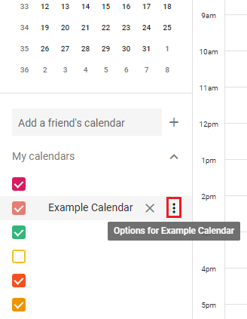

* 1. Click on “Settings and sharing”

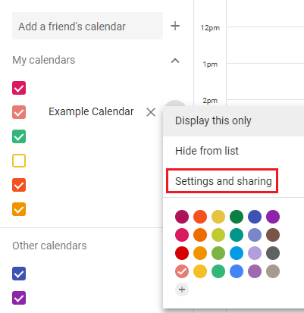

* 1. 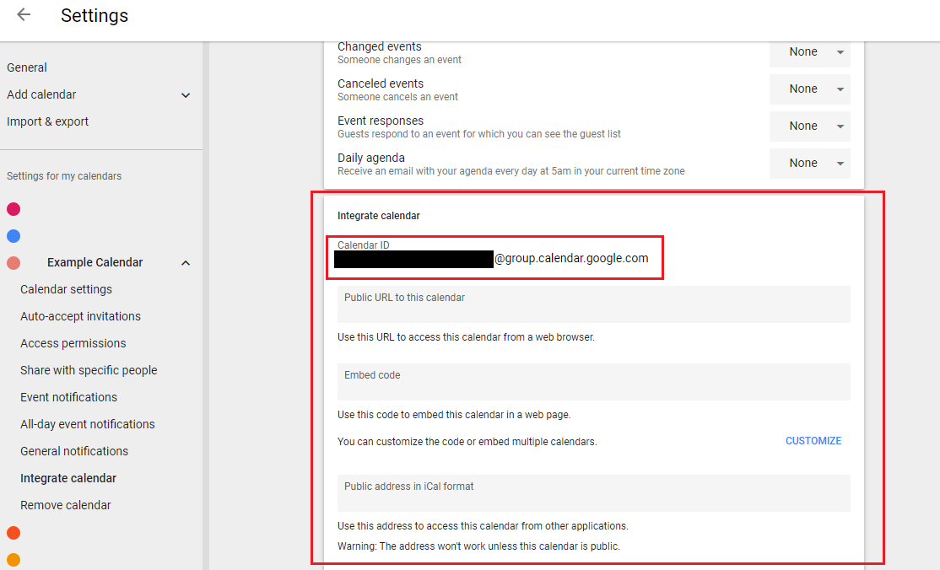Scroll down to “Integrate calendar” and copy calendar ID

1. Run the scheduler (without publishing)
   1. 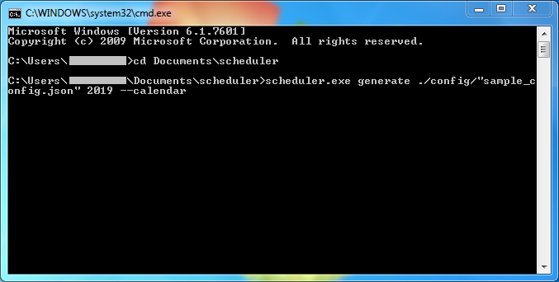Type: scheduler.exe generate ./config/“<config filename>” <year> --calendar , replacing <config filename> with the appropriate name chosen during the Configuration File Setup, the <year> with the year that the schedule should be generated for.
   2. Before pressing enter, right-click and select Paste to paste the calendar ID you copied in Step 3.
   3. Press enter to run the scheduler. The program will output the result, and if a feasible schedule was found, an excel file will be generated in the same folder.

**Note:** the first time you run scheduler.exe with the “--calendar” option, you will be asked to sign in to your Google calendar and grant permission to the scheduler application to read from and write to your calendars. Simply follow the instructions on the webpage that opens.

1. Publish the schedule
   1. Once you’ve verified that the schedule is correct, close the excel file
   2. Type: scheduler.exe generate ./config/“<config filename>” <year> --publish --calendar ,replacing <config filename> and <year> as in Step 4a, and pasting the calendar ID as in step 4b (note the additional option “--publish” that was not present in Step 4).
   3. 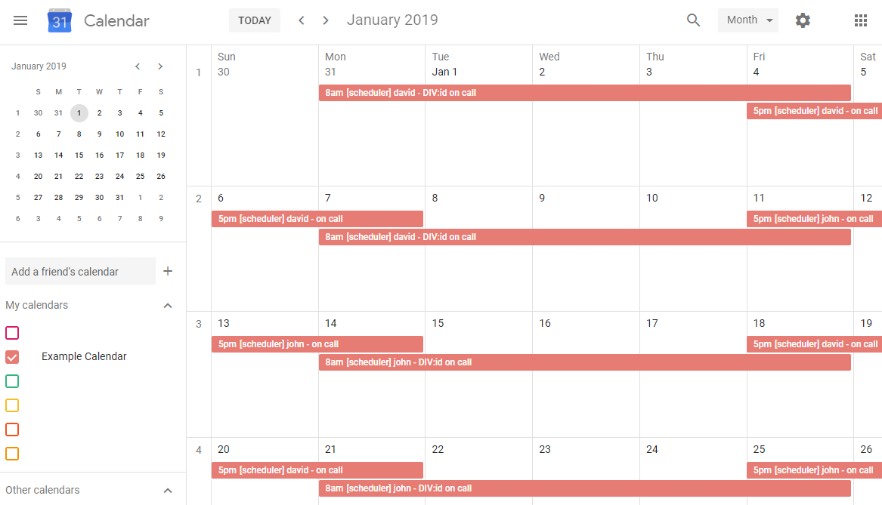Press enter. The program will now upload event corresponding to the schedule to the calendar you provided. The result may look like the following:

## Clearing the Schedule

Since the scheduler program generates and publishes many events, it may be tedious to delete them all one by one. Follow the instructions outlined below to delete any events created by the scheduler program.

1. Open a command prompt (Start 🡪 All Programs 🡪 Accessories 🡪 Command Prompt).
2. In the command prompt, navigate to the location of the programs.
   1. Type: cd <path\to\program> (replace with correct path) and press enter.
3. 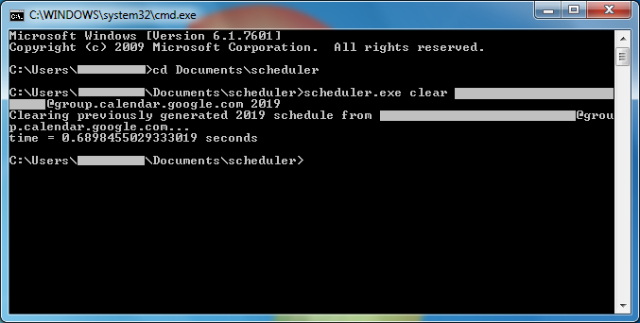Type: scheduler.exe clear <calendar ID> <year>, replacing <calendar ID> and <year> with the appropriate values as in the instructions for Running the Scheduler.

**Note**: the scheduler program will only clear the generated events for the supplied year.